**Table 1: Mean age at first flight in juvenile black and white-browed coucals**

|  |  |  |  |
| --- | --- | --- | --- |
| **Species** | **Sex** | **n** | **Mean age (in days) at first flight [95% CI]** |
| Black coucal | Female | 40 | 36.85 [34.71 - 38.99] |
| Black coucal | Male | 45 | 34.84 [32.73 - 36.94] |
| White-browed coucal | Female | 24 | 32.96 [29.57 - 36.33] |
| White-browed coucal | Male | 24 | 31.25 [28.46 - 34.03] |

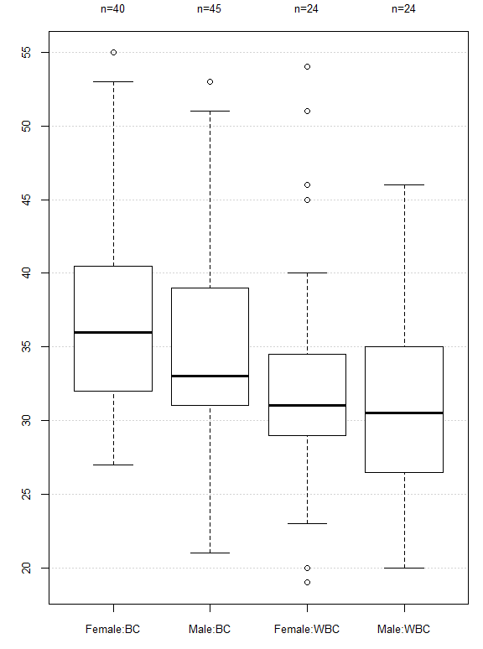

**Figure 1: Mean age at first flight in juvenile black and white-browed coucals**